**The Arthouse**

**The Arthouse and Library**

Stradbally, Co. Laois

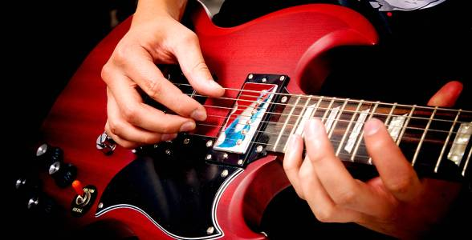

**Rehearsal Studio Available to Rent**

A professional rehearsal studio, equipped with state of the art digital drums, amps, and sound system etc. is available to all musicians and bands to rent.

* Spacious, carpeted sound proof room.
* Fully functional PA system with microphones & stands.
* Digital Drum Kit.
* Electric Guitar Amp.
* Bass Guitar Amp.
* All studios are cleaned daily and have in-house toilet facilities.
* Extra equipment is available to rent on request.

**Rehearsal Studios are open during the following times:**

**Monday – Friday**: 10am – 8pm

**Saturday**: 10am – 1pm

**Price per Hour**: *€10.00 + €100.00 refundable deposit

*NB: Your deposit of €100.00 will be refunded after your session is complete and the equipment checklist is confirmed.

**Call us today to book or view our Rehearsal Studio**

**The Arthouse and Library, Stradbally, Co.Laois**

**Ph: 057-864 1740 / Email:** [**artsoff@laoiscoco.ie**](mailto:artsoff@laoiscoco.ie)

** **

**The Arthouse and Library**

**and Library**

Stradbally, Co. Laois

**Rehearsal Studio Available to Rent**

A professional rehearsal studio, equipped with state of the art digital drums, amps, and sound system etc. is available to all musicians and bands to rent.

* Spacious, carpeted sound proof room.
* Fully functional PA system with microphones & stands.
* Digital Drum Kit.
* Electric Guitar Amp.
* Bass Guitar Amp.
* All studios are cleaned daily and have in-house toilet facilities.
* Extra equipment is available to rent on request.

**Rehearsal Studios are open during the following times:**

**Monday – Friday**: 10am – 8pm

**Saturday**: 10am – 1pm

**Price per Hour**: *€10.00 + €100.00 refundable deposit

*NB: Your deposit of €100.00 will be refunded after your session is complete and the equipment checklist is confirmed.

**Call us today to book or view our Rehearsal Studio**

**The Arthouse and Library, Stradbally, Co.Laois**

** Ph: 057-864 1740 / Email: artsoff@laoiscoco.ie**