a portrait project
nick miller

sitting: a portrait project by nick miller

IMMA and Laois County Council cordially invite you to the catalogue launch of Sitting, a portraiture residency by Nick Miller. Recent recipient of the inaugural Hennessy Portrait Prize, Miller was artist-in-residence in the Laois Arthouse, Stradbally, Co Laois, in July 2014. To be shown alongside the launch will be the screening of Sitting- a short film by Lisa Fingleton, which documents the experience.

Date: Thursday 4th December
Time: 1pm(sharp)
Location: the Lecture Room, followed by reception in the Johnston Suite, IMMA.
Launch by: Christina Kennedy, Senior Curator, head of Collections, IMMA.

RSVP: artsoff@laoiscoco.ie telephone 057-8664033

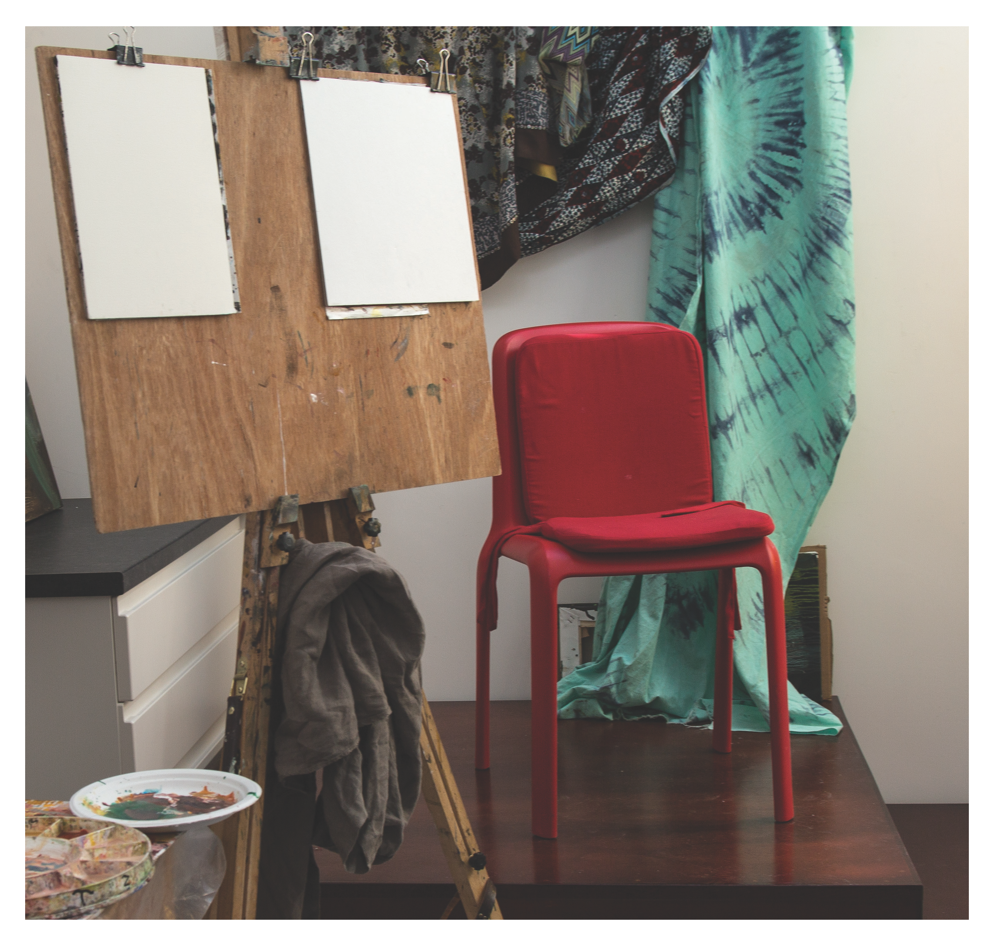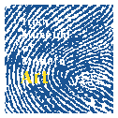This project was funded through the Department of Environment, percent for art scheme
la

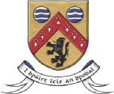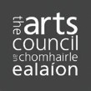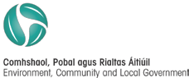laois arthouse

